# Integration Test:

|  |  |  |  |  |  |
| --- | --- | --- | --- | --- | --- |
| No | Test Title | Pre-condition | Test Steps | Expected Results | Actual results |
| 2 | Email sending of “International Student” query | Click on the “Information Query” button link from Online Learning menu | input all the form data and submit | The result was expected to store form data and mail will be sent to (demo)office email | As expected |

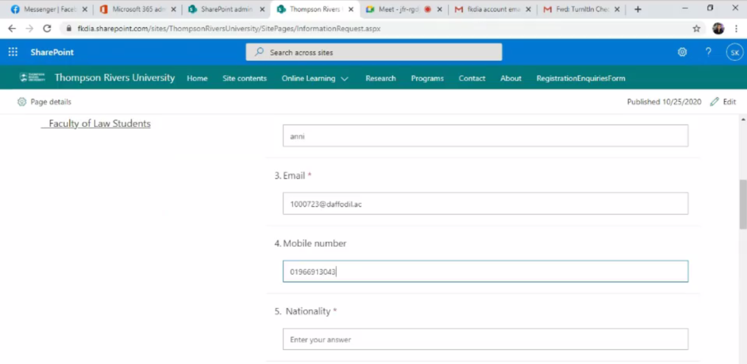

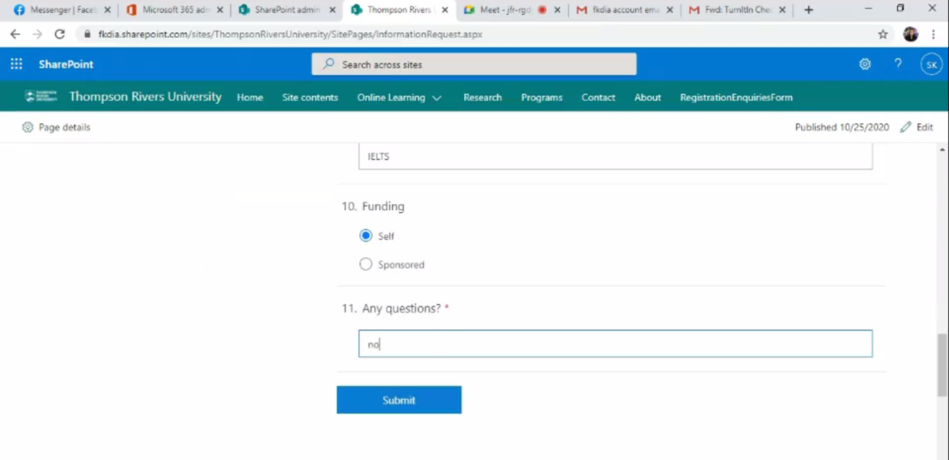

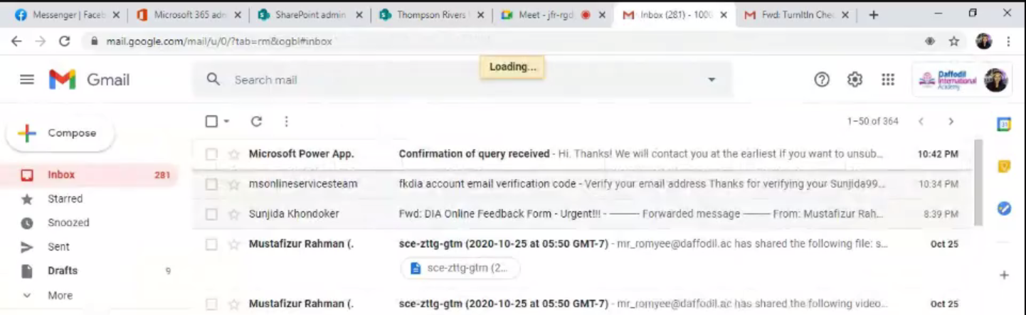

Figure 3, 4 and 5: Shows the processes of student query.